Kris Nichols

Dr. Soltoff

MACS 30200

**Abnormal Temperatures Affect Climate Change Behaviors and Attitudes**

Polls continue to reveal that the majority of American citizens support governmental intervention in limiting carbon output (Leiserowitz, Maibach, Roser-Renouf, & Feinberg, 2010; Leiserowitz, Maibach, Roser-Renouf, Feinberg, & Howe, 2013). Social scientists have sought to discover what creates the discrepancy between these polls’ results and election results, which continue to indicate a lack of care for mitigating the possible effects of climate change

(Popovich, Schwartz, Schlossberg, 2017). Existing studies – largely in the field of psychology – have attempted to address this discrepancy with studies of participant’s ideologies and attitudes, and possible changes in attitudes over time (Mccright, & Dunlap, 2011; Poortinga, Spence, Whitmarsh, Capstick, & Pidgeon, 2011). However, many of these studies were correlational and based on survey responses. Furthermore, in the case of huge national surveys, there has been a great deal of controversy about potentially crippling non-response bias, which often negatively impacts national opinion surveys (very similar to those included in the cited studies) (Brehm, 1993). In the context of these biases and limitations of survey methodology, I argue that the current literature investigating fluctuating American attitudes towards climate change is flawed. I propose to investigate this phenomenon using computational techniques that avoid the biases inherent in survey methodologies.

One focus of the literature investigating mechanisms of climate change attitude fluctuation has been to investigate how and why participants perceive the repercussions of climate change as distal, but a more critical question for interpreting the role of cognitive biases is how individuals change their beliefs and attitudes regarding climate change when they are confronted with repercussions such as abnormal temperatures or extreme weather events (Nerlich, Koteyko, & Brown, 2009; Spence, & Pidgeon, 2010). Some researchers have looked to investigate how climate change attitudes may change over time and be affected by a number of factors such as nearness to major elections, and abnormal temperature (Bergquist, & Warshaw, 2017; Brooks, Oxley, Vedlitz, Zahran, Lindsey, 2014). Concerning research investigating abnormal weather and climate change concern, there is the implicit assumption that individuals’ outside surroundings can influence their perception of risk – and indeed research shows this (Howe et al., 2014). Furthermore, research also indicates that support is stronger for climate protective policies following local abnormal weather events – lending more evidence to this theory (Rudman et al., 2013).

However, given the variation in survey response reliability, which can vary based on reactance, framing effects, observer-expectancy bias (when a participant may feel pressure to yield a certain result and acts accordingly), and several other biases – these studies should be taken with a measure of doubt (Balph &, Balph, 1983; Miller, 1976; Robins, Fraley, & Krueger, 2010). The weaknesses of the survey approach can also be found in the research conducted by Nerlich, Koteyko, & Brown (2009) where only single items from large surveys are used as their central dependent variable– for example, in the cited study it was a single item inquiring about climate change concern. The problem with such studies is that they are mostly devoid of explanatory power and lack the ability to give insight as to what mechanisms may be causing this concern or the lack thereof.

Moreover, existing studies that have considered how weather affects climate change attitudes only sought to measure the perceived concern towards climate change, a metric which is telling, but incomplete in accurately illustrating how temperature fluctuations may be altering behaviors and what mechanisms may be at play. For example, researchers investigating potential biases leading to climate change disbelief implicate a mechanism by which participants dispel the riskiness of climate change to dismiss its potential threat towards their conservative identity

(i.e., if climate change exists and has anthropogenic causes, then part of a conservative’s world view is flawed and this is threatening, so it is easier to deny climate change outright) (Mccright, & Dunlap, 2011). Supporting this claim, researchers found that even conservative individuals who self-report as “very knowledgeable” about climate change are often still in disbelief regarding its existence and may seek out means with which they can reinforce this disbelief (e.g., find aggregable opinions).

This cognitive bias implies a clear disconnect between climate change related behaviors and climate change attitudes that is troubling for the validity of survey measures simply inquiring about constructs such as concern or disbelief – that is, in the literature actions don’t perfectly map onto behaviors and this is troubling. It seems evident that if an individual indicates low climate change concern on a survey that they should also exhibit a low amount of behaviors that indicate concern about climate change. However, in line with the previously discussed identity protection bias, if an individual Google searches “climate change lies” multiple times a week to consume deliberately biased information, they are also likely to indicate low climate change concern on a survey measure begging the question - is this survey measure of concern truly accurate? Due to biases which may motivate individuals to inaccurately report their climate change attitudes, survey measures risk a lack of accuracy that threatens internal validity, highlighting again a need for newer more accurate measures of how individuals interact with the idea of climate change.

To address internal validity weaknesses in the literature, I propose taking a computational approach, which can provide data that measures participant’s real-time, organic responses to changes in temperature may more accurately reveal mechanisms, behaviors, and attitudes relating to climate change. Due to the biases and problems in the extant literature which investigates abnormal temperature’s role in climate change attitude fluctuation, there exists a need for further research to both contextualize previous results and integrate literature on cognitive biases with these ideas. Therefore, the central research question for this project is to investigate how abnormal temperatures may alter climate change attitudes and the mechanisms at play in this relationship using more representative computational data. Due to this change and others, this study should hopefully be able to provide a perspective on this research question that other studies in the literature have not.

Specifically, I hope to capture the benefits of two central qualities of “big data”: that these data are always on and that these data are nonreactive. Big data’s always-on quality is critical for this research due to its potential to alleviate the issue of a schism between individual climate change attitudes and behaviors. Although participants may consciously believe that they are not concerned about climate change their behaviors may indicate very different attitudes. For example, conservative participants may be biased to answer that they are not concerned about climate change due to the discussed identity protection mechanism, but their behaviors of concern such as searching for dissenting climate change information would indicate very different attitudes. The harnessing of this big data principle goes a long way towards improving the literature’s inability to measure behavior.

Furthermore, the harnessing of the nonreactive quality of big data also improves upon the past non-computational research by dampening the severity of survey-borne biases. As discussed, participants may be influenced by a number of biases that lead them to not indicate their true feelings concerning climate change. For example, there could be psychological reactance in past studies as a cause of the participants feeling that the researchers were directing towards a certain answer. The nonreactivity element of big data controls for this bias; participants’ behavioral and attitudinal data is collected without their knowing and big data consequently circumvent this bias.

To more adequately capture the entire picture of American attitudes and behaviors regarding climate change and the underlying mechanisms at play, I propose research in which Google search results regarding climate change are tracked across states which have experienced the largest and smallest average discrepancy in temperatures previous to the analyzed timeframe and after. Research finds that this data is unlikely to be biased by censoring and that most of individual’s “Googling” occurs when they are alone (Kreuter, Presser, & Tourangeau, 2009). This database has been used to capture nationwide trends; for instance, GoogleFlu has been found to accurately track flu epidemics showcasing the scale of explanatory and predictive power of the database. Dr. Stephens-Davidowitz has utilized Google search data to investigate hidden racist behaviors, showcasing the revelatory power of Google search data

(Ginsberg, Mohebbi, Patel, R. S., Brammer, Smolinski, & Brilliant, 2008; King, 2011; Stephens-Davidowitz, 2017). Because of the way literature indicates individuals often use the internet – without reservations for privacy – Google search data seems like a perfect tool to undermine some of the biases present in survey work (Conti and Sobiesk, 2007; Kornblum, 2005).

Furthermore, the internet is the second most common place where Americans receive their news, and Google is overwhelmingly the most popular search engine – if someone’s feelings about climate change fluctuate after abnormal temperatures and they want to learn more (or learn why they should not worry), these patterns should emerge here. But this measure is not without its limitations. It has led to potentially biased pictures of societal trends (as in GoogleFlu) and is not always ideal as a stand-alone database (Lazer, Kennedy, King, & Vespignani, 2014).

I believe, however, that this study has the ability to both strengthen the cases set forth by the previous literature investigating the effect of temperature on climate change and provide insight into potential mechanisms at work (Talhelm, Haidt, Oishi, Zhang, Miao, Chen, 2012). Previous research has only been able to comment on non-causal relationships, this project capitalizes upon more rigorous modeling techniques to probe into the forecasting and causal relationships between climate change attitudes and Google Search Data. To do this I propose the use of time-series analyses combined with supplementary OLS models as opposed to solely OLS models. This research uses Auto-Regressive Integrated Moving Average Modeling in addition to Bayesian Structural Time-Series Analysis to further investigate into the causal relationships at play. Furthermore, this project replicates the model of Konisky et al. (2016) to investigate the ability for Google correlates to improve upon the models of past researchers.

Researchers need to develop measures that are more flexible to the potential manifestations of changed climate change attitudes, if they hope to truly capture the mechanisms behind individual interactions with information on climate change, particularly when people are confronted with its repercussions. Google search data offers one source of data to more reliably investigate these shifting attitudes.

**Hypotheses**

I predicted that Google search data would have powerful utility in causal explanation and predictive power. I predicted that the OLS model with the regressors added from Google Correlate would have a lower MSE than the model without the regressors. Furthermore, I predicted that this model would become especially salient when concerning only the conservative states – which would fall in line with my theories regarding conservative’s needs to correct dissonance when confronted with the realities of climate change. I then predicted that the ARIMAX model would serve as a good fit of the relationship between Google search data and climate change attitudes due to the ability of ARIMAX to control for strong seasonal effects. Finally, I hope to learn more about the causal relationship between the Google data and climate change attitudes by making use of more powerful BTS. These results would confirm and strengthen the idea that attitudes do indeed change in reaction to fluctuating temperatures and would also warrant further investigation into what mechanism is causing conservative states to spike in climate change search activity with abnormal temperatures but yield little support for laws regarding it. This paper suggests a cognitive dissonance mechanism, in that participants in these conservative states perceive the abnormal temperatures, perceive some amount of worry regarding this phenomenon, and look up articles disproving climate change to sooth their dissonance.

# Methods/Data

For this study I use Google search data in combination with extreme weather and survey data to construct models which hope to explain climate change attitudes. I first construct a recreation of a model from Konisky et al. (2016) in which they built an OLS model using various survey measures in combination with extreme weather events to explain climate change attitudes. I construct their model as they did, and then add regressors which are Google correlates that map onto the 2010-2012 extreme weather data. The regressors are chosen through Least Absolute Shrinkage and Selection Operator (LASSO) regression. The model is then run as a LASSO regression to help control for the large amount of regressors.

I then construct ARIMAX models using the Google Correlate data and the full 2004-2017 extreme weather data to further investigate the relationship with the focus on the seasonality component. Finally I conduct exploratory analyses with Bayesian Structural Time (BTS) analysis.

## National Oceanic and Atmospheric Administration

In this study I am operationalizing extreme weather through data obtained from the

National Oceanic and Atmospheric Administration (NOAA, recently rebranded the NCEI). The NOAA contains a comprehensive dataset of weather, ranging from the 1950s to now. The data is collected by the National Weather Service (NWS) and is compiled with support from local and national NCEI climate centers. They collect a range of datasets including extreme weather events which they define as “the occurrence of storms and other significant weather phenomena having sufficient intensity to cause loss of life, injuries, significant property damage, and/or disruption to commerce.” Furthermore, the organization also documents events such “as record maximum or minimum temperatures or precipitation that occur in connection with another event” and track weather events perceived as “rare” weather phenomena that generate media attention.

These data are significant due to the organization’s documentation of “rare” weather events that often receive media attention, increasing the likelihood that they are seen by locals within the same state. This type of extreme weather data is a departure from the data used by the past literature that looks at abnormal weather only operationalized through abnormal temperatures (Bergquist, & Warshaw, 2017; Brooks, Oxley, Vedlitz, Zahran, Lindsey, 2014).

This data allows for a new angle on the types of weather that affect climate change attitudes. Although it has been demonstrated that abnormal temperatures affect climate change concern it makes intuitive sense that many of other extreme weather events generate interest in climate change. This is especially true given media’s increased attention to odd events (e.g., snow in April), This data is available for download through the NOAA website on the Storm Events Database page. For the purposes of this study, I have collected only certain types of extreme weather events, although up to 48 are available. I have designated the extreme weather events pertinent to this study as those designated by the National Climate Assessment Council (NCA, 2014): excessive heat, flash floods, flood, heat, heavy rain, tropical storms, and hurricanes (see Figure 1 for composition of events). I run initial analyses on the relationship between national incidences of extreme weather and Google data. I analyze three states with the highest amount of extreme weather and three states with the lowest amount of extreme weather in order to discover any ideological differences in the interaction between extreme weather and Google search data. I take one conservative state, one liberal state, and one swing state to represent each group of extreme weather (e.g., the liberal state with the highest amount of extreme weather events and the liberal state with the lowest amount of extreme weather events) (see Figures 3 and 4 for the compositions of each of these groups).

I calculate conservativism/liberalism by taking state-level data from the two closest presidential elections: 2008 and 2010. States with the highest combined voting percentage for the conservative candidate were coded as conservative, those with the lowest were coded as liberal, and those within .05 of 1 (i.e., .5 percent on average each year) were coded as swing states. The swing states included in the state-level analyses for this study are Missouri (extreme weather events 2010-2012= 1910) and Florida (n = 466). The conservative states included are Kentucky (n = 1658) and Alaska (n = 48), and the liberal states are Illinois (n = 1603) and Rhode Island (n=39). This data has recently been used by Konisky et al. (2016) in investigating survey reports data and extreme weather event data.

When building time-series models of the entire 2004-2017 NOAA dataset the same method is used except for the 2004, 2008, 2012, and 2016 elections. However, for this time series I use Texas (n = 18205) and Wyoming (n= 333) as the two conservative states with the most and least amount of extreme weather, respectively. The two swing states used for this time period are Missouri (n = 8898) and New Hampshire (n = 448). The two liberal states are Illinois (n = 6071) and Rhode Island (n=242).

## Cooperative Congressional Election Study

I also analyze the Cooperative Congressional Election Study data to replicate the model of a study by Konisky et al. (2016) which also analyzed the relationship between abnormal weather and political attitudes. I replicate their model without the Google search data and, I then include Google correlate terms into the OLS methodology they implemented to demonstrate how Google search data is able to improve the predictive power of their model. This data is collected in two waves during election years: pre-election and post-election, in nonelection years the data is simply collected once a year. I use the years 2010-2012 to recreate the models used by Konisky (2016). The central dependent variable from this survey data is climate change concern, measured by a 5-point likert scale asking about participant’s feelings about climate change. The model involves regressors of age, sex, minority status, married, income, education, church attendance, political ideology, and democratic or republican status. I then add the strongest Google Correlates associated with extreme weather data from 2010-2012 to this model to investigate whether these data can improve predictive accuracy. The original model is based on the code acquired from Konisky himself, although I implement least absolute shrinkage and selection operator (LASSO) regression in order to account for the large amount of regressors included in the original model.

## Google Search Data

I implement the usage of both Google Correlate Data for this study. Google Correlate is able to find Google queries that are correlated with other Google queries and can also find queries that are correlated with user-supplied data. In this instance, I load the compiled extreme weather NOAA data into Google Correlate and use the returned correlates to build upon the model of Konisky and form my own ARIMA models. As many of the correlates are likely be spurious, I use stepwise regression and LASSO regression in addition to theoretical bases to help choose the correct correlates to include in the modified model. Any initial trends in Google search terms are also visible here.

## Models

For this study I implement several modeling techniques. To first replicate the model of Konisky et al. (2016) with Google Correlate terms I use simple OLS modeling. I also implement stepwise regression to choose correlates from Google Correlate to include in this model. For the main findings of the paper I implement Auto-regressive Integrated Moving Average (ARIMA) modeling to first establish a strong model with the 2010-2012 extreme weather data I end up choosing a (1,1,0) ARIMA model – indicating a 1st order auto-regressive model. Finally, I make use of Bayesian Structural Time Series (BSTS) modeling to investigate causal mechanisms in a way that ARIMA is unable to, that is, BSTS allows for modeling of both regression components and time series components.

**Results**

The final OLS model specified by Konisky et al. (2016) includes measures of demographics, extreme weather events, and political attitudes. In recreating the exact model of these researchers I get a MSE of 0.827331 while I get a slightly lower MSE of 0.8268317 when I introduce the Google Correlates into the model. When specifying only conservative states with the highest and lowest amounts of abnormal weather (Kentucky for the 2010-2012 data) I still receive a very modest MSE of 0.8589807. I introduced three Google Correlates that were first narrowed with stepwise regression and then chosen using theoretical bases. The three chosen correlates were Google queries for heat related illnesses. These MSEs are quite poor and cursory glances at the Google Correlates related to the extreme weather data gives an idea as to why – this data is *extremely* seasonal (Figures 12 and 6). Many of the Google Correlates returned have to do with summer activities, the period in which extreme weather typically peaks. Because of this, theoretical validation is given for the use of ARIMA methodology which specializes in removing these kinds of seasonal effects.

Initial graphs of the data suggested a seasonal trend in the data (Figure 2) and initial time-series plotting confirms this (Figure 6). Using decomposition I decompose the seasonal effect and “de-seasonalize” the data (Figure 7). Running an Augmented Dickey-Fuller (ADF) test on this data determines whether it is stationary or not and results indicate p=.082 indicating a failure to reject the null, confirming a non-stationary time-series.

|  |  |  |  |
| --- | --- | --- | --- |
| Test Statistic | Lag Order | P-Value | Alternative Hypothesis |
| -3.359 | 3 | .08184 | Stationary |

Graphing the auto-correlation function (ACF) plot (Figure 8) illustrates that there several significant auto correlations (past the blue dotted line) but these auto correlations could be driven by the strong correlation of the first two lags, as seen in the partial-ACF plot (Figure 9). I difference the time-series by d=2 and produce a p=.04 on another ADF test, rejecting the null and confirming a stationary time-series. I finally fit an ARIMA model with (1,1,0) using the auto.arima() function resulting in a model of: Ŷdt=0.4226Yt-1+𝔼 and summary stats:

|  |  |  |  |  |  |  |
| --- | --- | --- | --- | --- | --- | --- |
| ME | RMSE | MAE | MPE | MAPE | MASE | ACF1 |
| 9.77779 | 53.56872 | 39.13891 | .8285617 | 3.126874 | .1345383 | -.0192799 |

The ARIMA function fits the extreme weather data well, although it could be improved upon. When I add the correlates as regressors (making this an ARIMAX model) the model performs even better:

|  |  |  |  |  |  |  |
| --- | --- | --- | --- | --- | --- | --- |
| ME | RMSE | MAE | MPE | MAPE | MASE | ACF1 |
| -7.547543e- | 0.225371 | 0.1993406 | -0.003263 | 0.02325411 | 0.0003987267 | -0.10633 |

although this time the ARIMA takes the form of a White Noise model (1,0,0).

Finally, I look to expand these promising results to the entirety of the 2004-2017 extreme weather data set. Conducting an ARIMAX model again with the same method of choosing Google Correlate Regressors I fit an ARIMA (1,0,0) model (Figure 11).

|  |  |  |  |  |  |  |
| --- | --- | --- | --- | --- | --- | --- |
| ACF1 | ME | RMSE | MAE | MPE | MAPE | MASE |
| 0.7311344 | 318.6597 | 241.41 | -21.49369 | 39.22425 | 0.666657 | -0.005412 |

This model fits pretty well as well. Thus far I have been able to confirm a relationship between extreme weather events and climate change Google Searches on the national level but have been unable to prove the same trends at the state level. To further probe the relationship between these Google Searches I implement BTS modeling to get a better idea of causality (Figure 13). The advantage of this type of modeling is that it gives an idea of seasonality and the regression results as well. As can be seen in Figure 13 there is not much of a trend, but a severe seasonal effect exists. Although flawed, R2 gives us an idea that the model seems to be functioning modestly well with an R2 of .7588.

**Conclusions**

Although I was unable to confirm the hypothesis of state-level differences in Google Search data I was able to confirm that there is certainly a relationship here that demands more investigation. The OLS models used by many of the past researchers are unequipped to deal with the strong seasonality of these data and combined with the errors borne by their survey methodologies the reliability of this literature is in question.

Some of the limitations of this study includes its reliance on Google Correlate data. Although state and nation wide Google Correlate data were used the addition of Google Trends data may have made for a stronger case for the state-level relationships I hypothesized. Furthermore, as with much of the research interpreting Google Search Data there is the issue of causality – or, what do these results mean? I endeavored to limit the inclusion of specious or spurious regressors from the list of Google Correlates by utilizing LASSO regression and stepwise regression when necessary, but this adds little to my ability to causally interpret what relationship occurs between each individual correlate and the extreme weather data.

If given more time I would like to further investigate these relationships through the use of Google Trends data and media scraping to investigate the role of the media in the population’s climate change concerns.

**References**

Balph, D., Balph, M. (1983). On the Psychology of Watching Birds: The Observer Expectancy Bias.

*American Ornithological Society, 100*, 755-757.

Bergquist, P., & Warshaw, C. (2017). Beyond politics: Climate concern responds to changing temperatures in the American states. *MIT Urban Planning*.

Brehm, J. (1993). *The Phantom Respondents.* Ann Harbor: University of Michigan Press.

Brooks, J., Oxley, D., Vedlitz, A., Zahran, S., & Lindsey, C. (2014). Abnormal Daily Temperature and Concern about Climate Change Across the United States. *Review of Policy Research,31*(3), 199-217.

Conti, G., & Sobiesk, E. “An Honest Man Has Nothing to Fear,” in Proceedings of the 3rd Symposium on Usable Privacy and Security - SOUPS ’07. ACM Press New York, New

York, USA. p. 112

Gifford, R. (2011). The dragons of inaction: Psychological barriers that limit climate change mitigation and adaptation. *American Psychologist,66*(4), 290-302. doi:10.1037/a0023566

Ginsberg, J., Mohebbi, M. H., Patel, R. S., Brammer, L., Smolinski, M. S., & Brilliant, L. (2008).

Detecting influenza epidemics using search engine query data. *Nature,457*(7232), 1012-1014.

Howe PD, Boudet H, Leiserowitz A, Maibach EW (2014) Mapping the shadow of experience of extreme weather events. Clim Chang 127(2):381–389

King, L. (2011). The Social Science Data Revolution [PowerPoint slides]. Retrieved From <https://gking.harvard.edu/files/gking/files/evbase-horizonsp.pdf>

Konisky, D. M., Hughes, L., & Kaylor, C. H. (2016). Extreme weather events and climate change concern. *Climatic change*, *134*(4), 533-547.

Kornblum, J. (2005). Teens Wear Their Hearts on Their Blog. Retrieved January 25, 2018, from <https://usatoday30.usatoday.com/tech/news/techinnovations/2005-10-30-teen-blogs_x.htm>

Kreuter, F., Presser, S., & Tourangeau, R. (2009) Social Desirability Bias in CATI, IVR, and Web Surveys: The Effects of Mode and Question Sensitivity. Public Opinion Quarterly, 72

(5), 847–865.

Lazer, D., Kennedy, R., King, G., & Vespignani, A. (2014). The Parable of Google Flu: Traps in Big

Data Analysis. *Science,343*(6176), 1203-1205.

Leiserowitz, A., Maibach, E. W., Roser-Renouf, C., & Feinberg, G. (2010). Climate Change in the American Mind: Americans Global Warming Beliefs and Attitudes in June 2010. *SSRN Electronic Journal*.

Leiserowitz, A., Maibach, E. W., Roser-Renouf, C., Feinberg, G., & Howe, P. (2013). Climate Change in the American Mind: Americans Global Warming Beliefs and Attitudes in April 2013. *SSRN Electronic Journal*.

Poortinga, W., Spence, A., Whitmarsh, L., Capstick, S., & Pidgeon, N. F. (2011). Uncertain climate: An investigation into public scepticism about anthropogenic climate change. *Global Environmental Change,21*(3), 1015-1024.

Popovich, N., Schwartz, J., & Schlossberg, T. (2017) How Americans Think About Climate Change in Six Maps. *The New York Times*. Retrieved from [https://www.nytimes.com/interactive/2017/03/21/climate/how-americans-think-about-c](https://www.nytimes.com/interactive/2017/03/21/climate/how-americans-think-about-)limatechange-in-six-maps.html

Mccright, A. M., & Dunlap, R. E. (2011). Cool dudes: The denial of climate change among conservative white males in the United States. *Global Environmental Change,21*(4), 1163-1172.

Miller, R. L. (1976). Mere exposure, psychological reactance and attitude change. *PsycEXTRA*

*Dataset*.

Nerlich, B., Koteyko, N., & Brown, B. (2009). Theory and language of climate change communication. *Wiley Interdisciplinary Reviews: Climate Change,1*(1), 97-110.

Robins, R. W., Fraley, R. C., & Krueger, R. F. (2010). *Handbook of research methods in personality psychology*. New York: Guilford.

Rudman LA, McLean MC, Bunzl M (2013) When truth is personally inconvenient, attitudes change the impact of extreme weather on implicit support for green politicians and explicit climate-change beliefs. Psychol Sci 24(11):2290–2296

Scheitle, C. P. (2011). Googles Insights for Search: A Note Evaluating the Use of Search Engine Data in

Social Research*. *Social Science Quarterly,92*(1), 285-295.

Spence, A., & Pidgeon, N. (2010). Framing and communicating climate change: The effects of distance and outcome frame manipulations. *Global Environmental Change,20*(4), 656-667.

Stephens-Davidowitz, S. (2017). *Everybody Lies: Big Data, New Data, and What the Internet can Tell us*

*About Who we Really are*. Harper Collins.

Talhelm, T., Haidt, J., Oishi, S., Zhang, X., Miao, F., & Chen, S. (2012). Liberals Think More

Analytically (More Weird) than Conservatives. *SSRN Electronic Journal*.

**Appendices**

## Figure 1

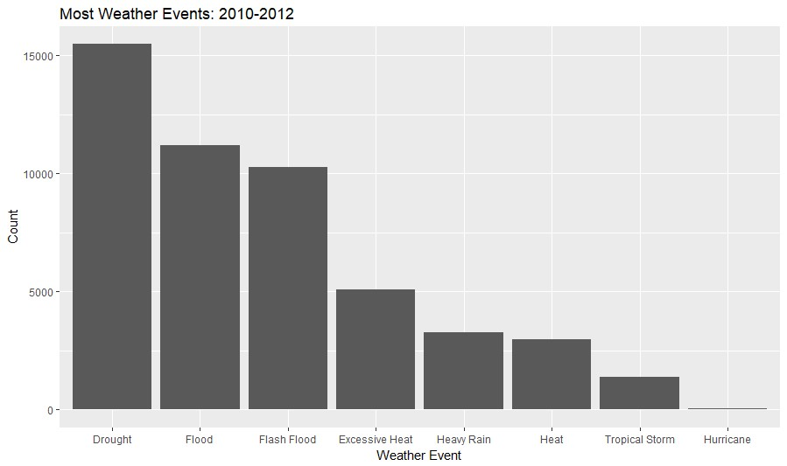

## Figure 2

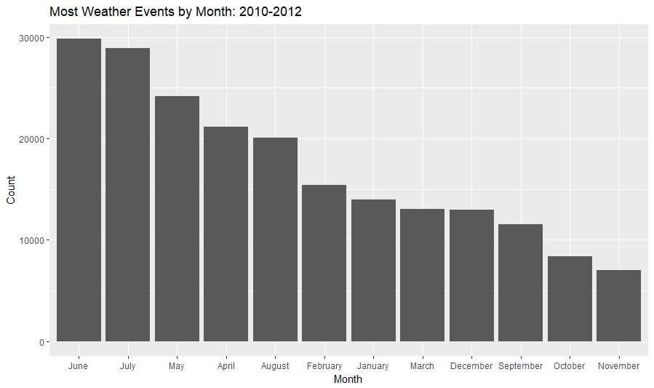

## Figure 3

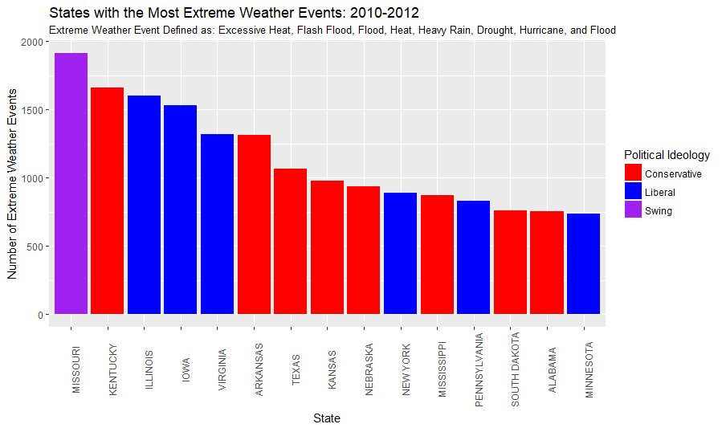

## Figure 4

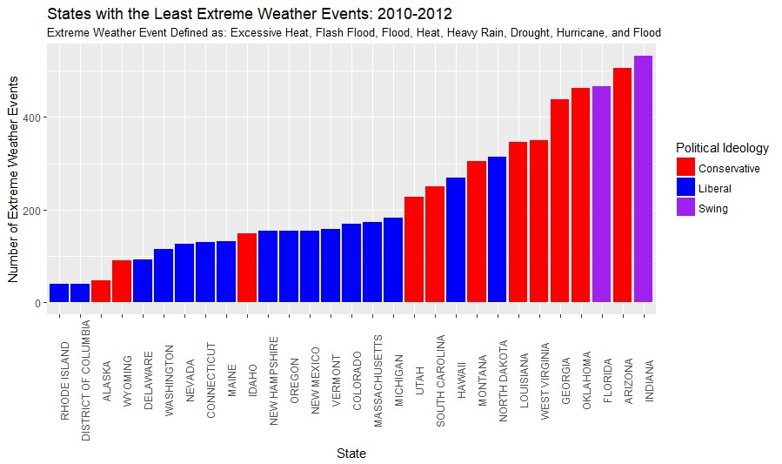

## Figure 5

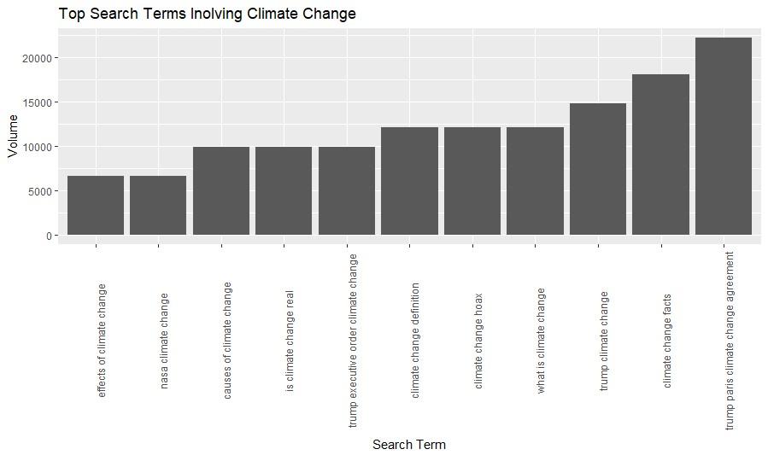

## Figure 6

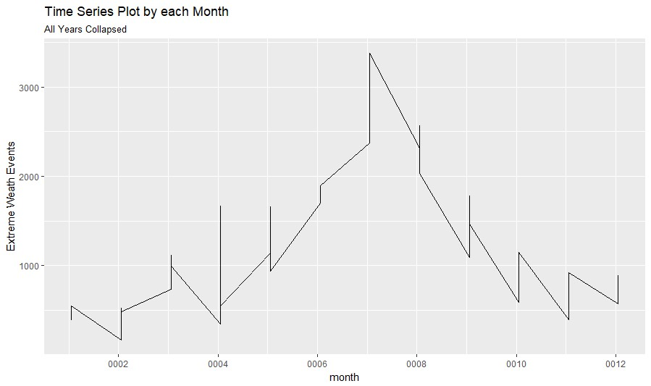

## Figure 7

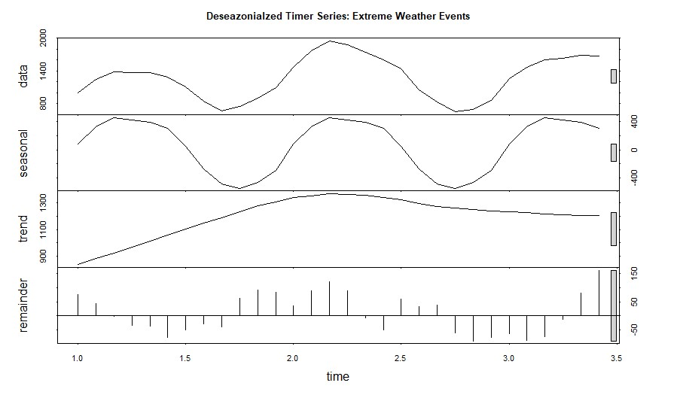

## Figure 8

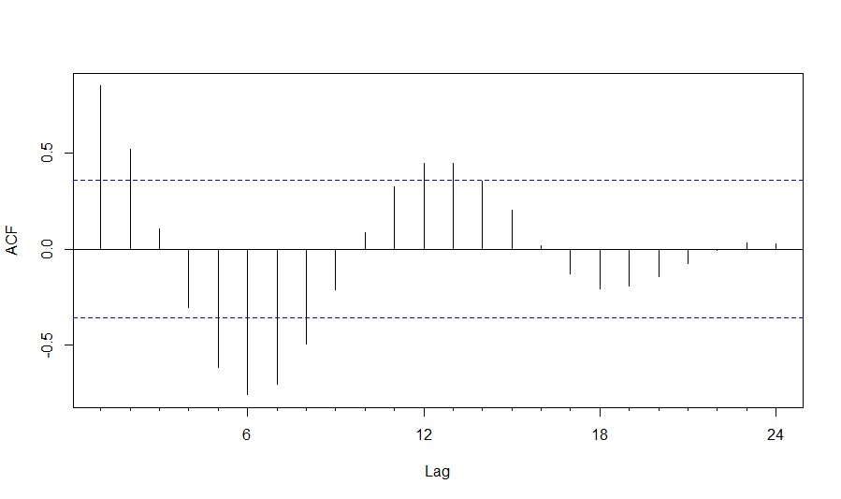

## Figure 9

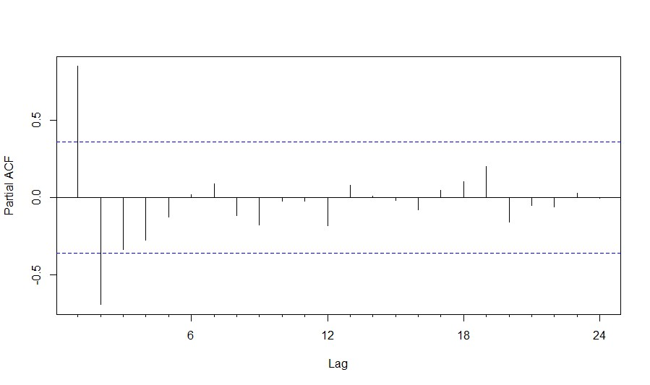

## Figure 10

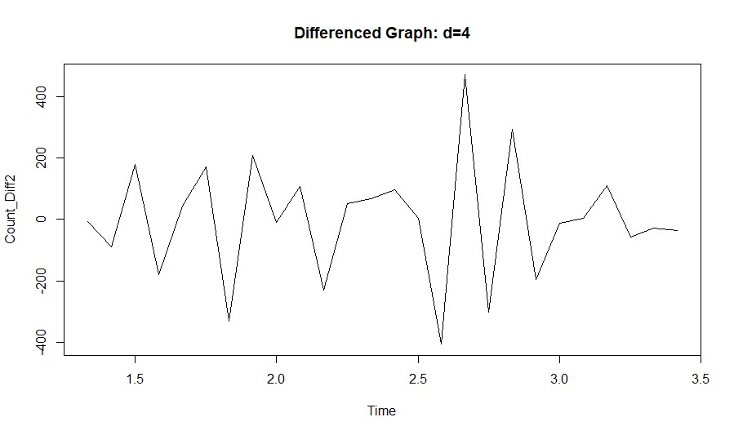

**Figure 11**

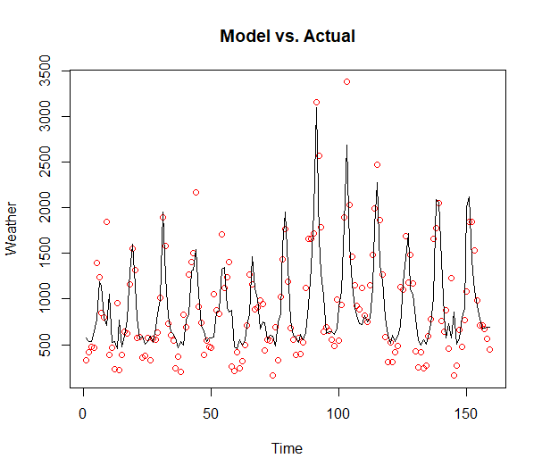

**Figure 12**

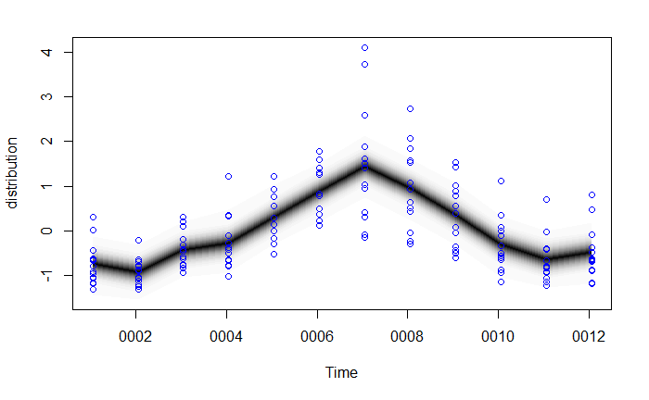

**Figure 13**

